PROJECT REPORT — PASSWORD GENERATOR

Project Title: TO-DO List
Internship: DecodeLabs Internship Program
Submitted By: _Hiba Rani

Course: Internship

Submitted To: DecodeLabs

Submission Date: 15-4-2026

Title
Random Password Generator using Python

1. Introduction
The Password Generator is a Python application that creates secure and random passwords based on user requirements. It enhances understanding of randomness and string manipulation.

2. Objectives
- To generate strong passwords
- To use random module
- To handle strings and characters

3. Technologies Used
- Python
- CLI

4. Features
- Generate random passwords
- User-defined password length
- Combination of letters, digits, symbols

5. Methodology

Input:
- User enters desired password length

Process:
- Random characters are selected
- Characters are combined to form password

Output:

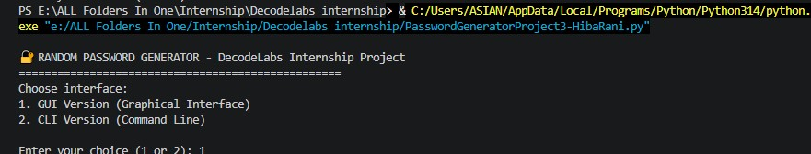
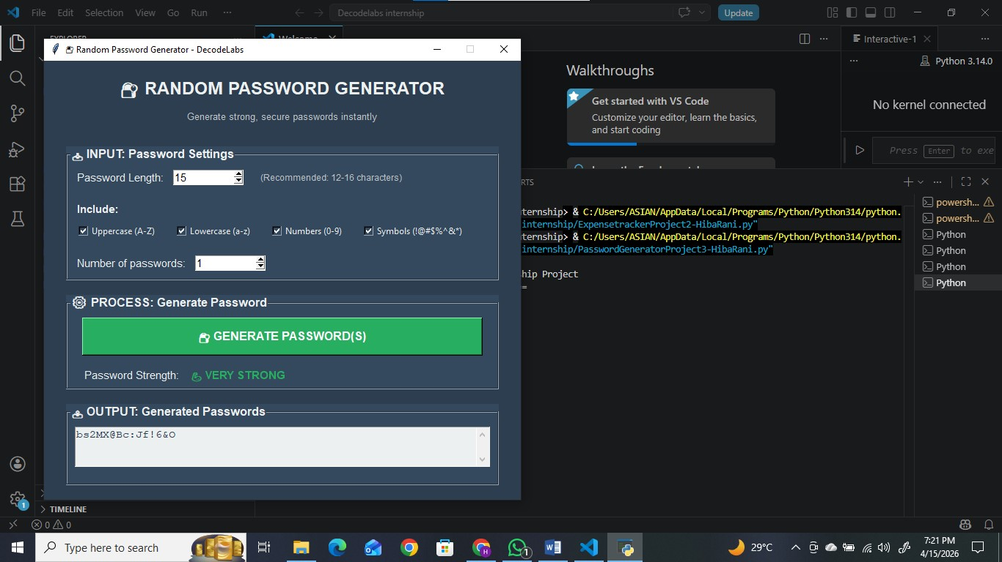
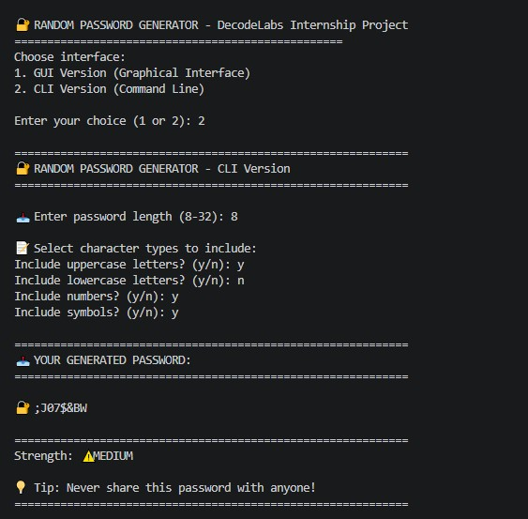

6. Code Explanation
- Uses random module
- Uses string characters (letters, digits, symbols)
- Loop generates password of required length

7. Output

8. Conclusion
This project improves understanding of randomness and secure coding practices.

“This project was developed as part of DecodeLabs Internship to strengthen practical programming skills.”

